Ex.No: 18
Date:

Aim:

HIGH LEVEL LANGUAGE EXTENSION WITH CURSORS

To implement Cursors using program in MySQL.

Description:
A cursor is used to process database records one by one. In MySQL, an explicit cursor can be created by the user for row-by-row processing.
The basic steps are:
- Declare the cursor.
- Declare a handler for the end of the records.
- Open the cursor.
- Fetch records one by one.
- Close the cursor.

How to create Explicit Cursor:
- Declare Cursor Object.
Syntax : DECLARE cursor_name CURSOR FOR SELECT * FROM table_name

- Open Cursor Connection. Syntax : OPEN cursor_connection

Fetch Data from cursor.
There are total 6 methods to access data from cursor. They are as follows :
FIRST is used to fetch only the first row from cursor table.
LAST is used to fetch only last row from cursor table.
NEXT is used to fetch data in forward direction from cursor table. PRIOR is used to fetch data in backward direction from cursor table. ABSOLUTE n is used to fetch the exact n^{th} row from cursor table.
RELATIVE n is used to fetch the data in incremental way as well as decremental way.

Syntax : FETCH NEXT/FIRST/LAST/PRIOR/ABSOLUTE n/RELATIVE n FROM cursor_name

- Close cursor connection. Syntax : CLOSE cursor_name

Deallocate cursor memory.
Syntax : DEALLOCATE cursor_name

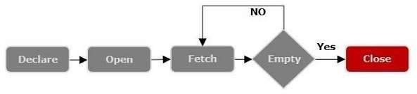

Problem- 1
Write a Cursor program using MySQL to retrieve the email-ids(build an email list) of employees from employees table.

SOLUTION :
create table employees(id integer, Name varchar(100), email varchar(100));
insert into employees(id, Name, email) values(1, "Harry Potter", "pharry@warnerbros.com"); insert into employees(id, Name, email) values(2, "Clark Kent","kclark@dccomics.com"); insert into employees(id, Name, email) values(3, "Tony Stark", "stony@marvel.com");

DELIMITER $$
CREATE PROCEDURE build_email_list (INOUT email_listvarchar(4000)) BEGIN
DECLARE v_finished INTEGER DEFAULT 0; DECLARE v_emailvarchar(100) DEFAULT "";

-- declare cursor for employee email

DECLAREemail_cursor CURSOR FOR

SELECT email FROM employees;
-- declare NOT FOUND handler DECLARE CONTINUE HANDLER FOR
NOT FOUND SET v_finished = 1;

OPEN email_cursor; get_email: LOOP

FETCH email_cursor INTO v_email; IF v_finished = 1 THEN
LEAVE get_email;

END IF;
-- build email list
SET email_list = CONCAT(v_email,";",email_list);

END LOOP get_email; CLOSE email_cursor;

END$$ DELIMITER ;

-- Calling the procedure and getting the email list

SET @email_list = "";
CALL build_email_list(@email_list); SELECT @email_list;

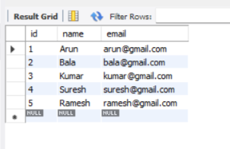

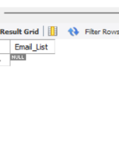

RESULT:
Thus the Cursor program using MySQL is executed successfully.

